**NETWORK DIAGRAM:** 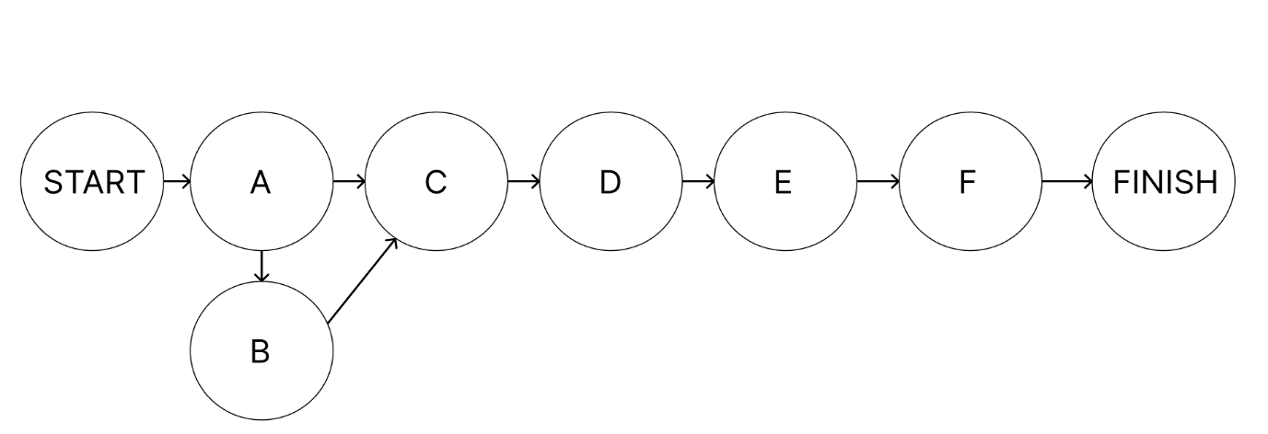

USER STORIES INCLUDED IN DIFFERENT TASKS:

TASK A: 1,2,5,6,14,17,22,32,35,37,40

TASK B: 3,9,21,27,34

TASK C: 4,12,20,23,24,25,36

TASK D: 7,8,11,18,26,28

TASK E: 10,15,16,29,31,33,38

TASK F: 13,19,30,39

USER STORIES:

1=As a user, I want to create a new job with a unique identifier, so that I can track individual jobs in the system.

2= Assign jobs to specific workers.

3=validate inputs for job dependencies.

4= Implement storage for job data using serialized text files.

5= Delete a job from the schedule.

6= Edit the details of an existing job.

7= Set dependency relationships between jobs.

8= Mark jobs as completed.

9= Prevent overlapping jobs for the same worker.

10= View a list of existing jobs.

11= As a user, I want to assign priorities to the job.

12= Export the job schedule as a text report.

13= Create recurring jobs.

14= Log changes to jobs(e.g.: edits, deletions).

15=Visualize the job schedule.

16= Pause and resume jobs.

17= Cancel jobs that are no longer needed.

18= As a user i want jobs to be scheduled based on system load.

19= As a user i want to receive an email notification for job failure.

20= View a historical list of completed jobs.

21= Display error messages for missing job fields.

22= As a user I want to cancel all jobs at once.

23= Filter jobs based on their statuses (e.g. completed , pending).

24= Specify start and end dates for a job.

25= See estimated completion time for each job.

26= Sort jobs by priority.

27= Validate each job entry.

28= Change job priority after creation.

29= Search for jobs by keywords.

30= Notifications for job start.

31=Assign custom tags to jobs.

32=Finalize scheduled job.

33=Filter jobs based on custom tags

34= Implement error handling for invalid input

35=Write unit tests for job creation and deletion

36=Generate a summary report for job statuses

37=Auto-generated job ids based on predefined rules

38=Adjust visibility of jobs based on user roles

39=Set Alert for Job Deadlines

40=Log user actions for audit purposes

**PERT CHART:**

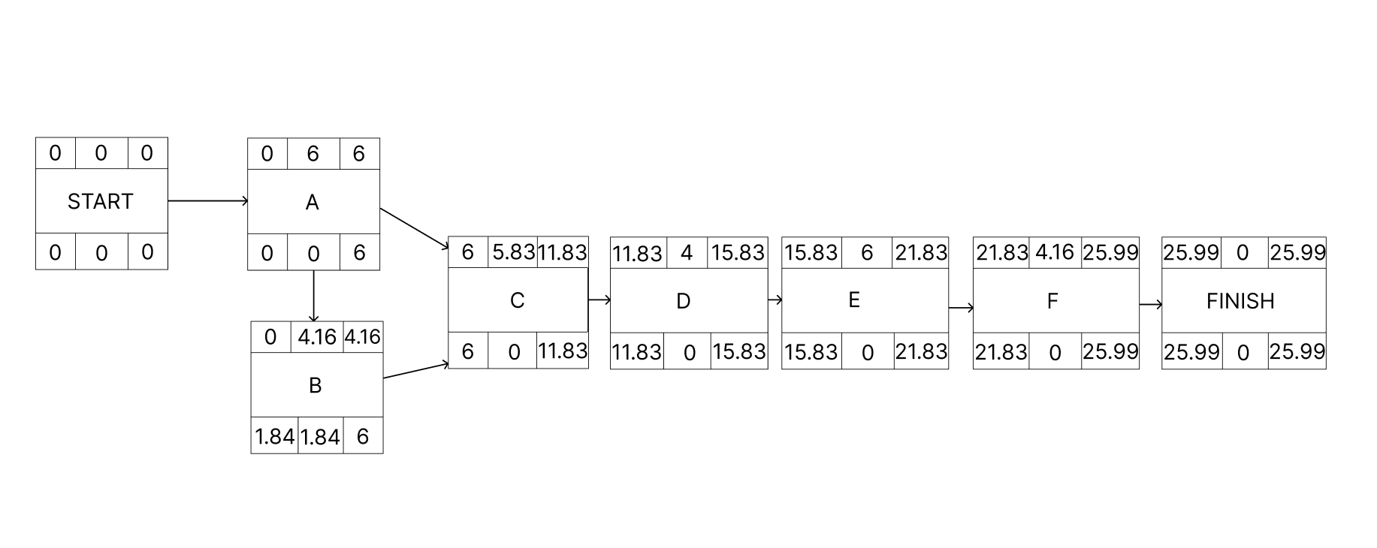

**IN ABOVE PERT CHART THE CRITICAL PATH IS START, A, C, D, E, F AND FINISH.**

|  |  |  |  |  |  |  |  |  |  |
| --- | --- | --- | --- | --- | --- | --- | --- | --- | --- |
| |  | | --- | | **Activity** |  |  | | --- | |  |  |  | | --- | |  |  |  | | --- | |  | | **Predecessors** | **Optimistic** | **Most Likely** | **Pessimistic** | **Expected**  **Time** |
| **A** | None | 5 | 6 | 7 | 6 |
| **B** | A | 3 | 4 | 6 | 4.16 |
| **C** | A,B | 5 | 6 | 6 | 5.83 |
| **D** | A | 3 | 4 | 5 | 4 |
| **E** | A | 5 | 6 | 7 | 6 |
| **F** | A,B | 3 | 4 | 6 | 4.16 |